# Lab 3. Dynamic Routing OSPF with Authentication

# Topology

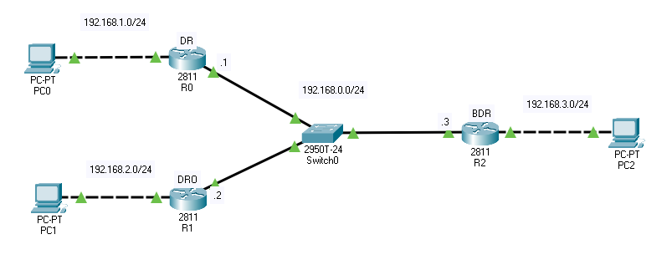

# Interface config

Router(config)#hos R0

R0(config)#int fa0/0

R0(config-if)#ip address 192.168.0.1 255.255.255.0

R0(config-if)#no shut

R0(config)#int fa0/1

R0(config-if)#ip address 192.168.1.1 255.255.255.0

R0(config-if)#no shut

# OSPF Config

R0(config)#router ospf 10

R0(config-router)#network 192.168.0.0 0.0.0.255 area 0

R0(config-router)#network 192.168.1.0 0.0.0.255 area 0

R0(config-router)#ex

***\*R1 & R2 as the same***

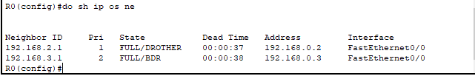

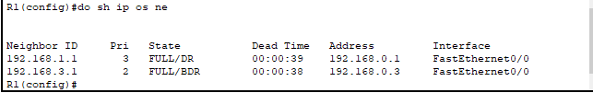

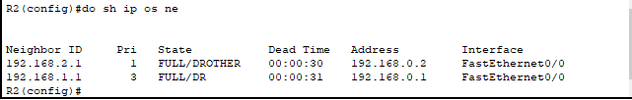

# Authentication

## Using Plain text

R0(config)#int fa0/0

R0(config-if)#ip ospf authentication-key plainpas

R0(config-if)#ip ospf authentication

R0(config-if)#ex

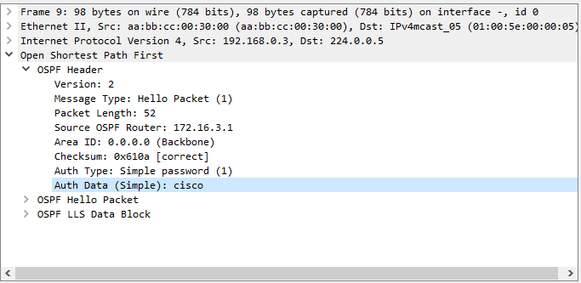

## Using MD5 Encrypt

R0(config)#int fa0/0

R0(config-if)#ip ospf message-digest-key 1 md5 keymd5

R0(config-if)#ip ospf authentication message-digest

R0(config-if)#ex

## 